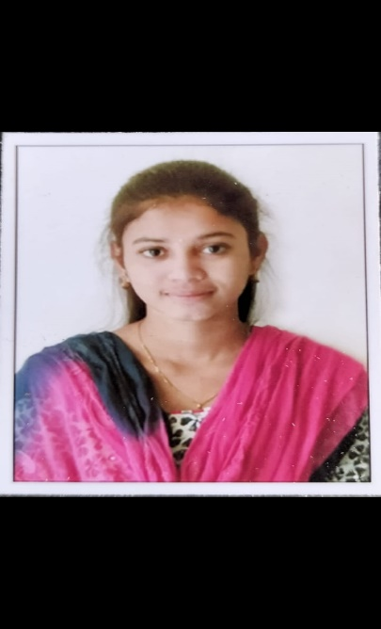

Sanchi Nischitha

# SKILLS

* Python
* HTML, CSS
* C Language

# LANGUAGES

* English
* Tamil
* Telugu

# CONTACT INFORMATION

**Address:**

Ramapuram(vi),

Nellore(dis)-524127

Andhrapradesh

**Phone**:

+91 7893999035

**Email:**

nischithasanchi14379@gmail.com

## OBJECTIVES

An enthusiastic student with good leadership and communication skills seeking good role in your reputable organization which will enhance my skills and contribute in the growth of the organization.

### EDUCATION

2017

T M R high school

* 10th
* 90%

2019

Sri Chaitanya Junior College

* 12th
* 88%

2019 - 2023

Saveetha Engineering College

* B.Tech (computer science and engineering)
* 8.5 CGPA

### PROJECTS

* **Mini Project**

Speech Emotion Recognition: The attempting to recognize human emotion and affective states from speech

### 

### PERSONAL DETAILS

* Date of Birth: 13/02/2001
* Age : 21
* Gender : Female
* Nationality : Indian

### INTEREST:

* Travelling
* Cooking
* Gardening

### DECLARATION

* I hereby declare that all the details stated above are true and correct to the best of my knowledge